Table outlining Paris Métro stations
Station | Photo | Code | Line | Zone | Arrondissement | Opened | Notes
Abbesses | 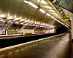 | 31-05 | 12 | 1 | 18 | 31 October 1912
Alésia | 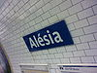 | 15-05 | 4 | 1 | 14 | 30 October 1909
Alexandre Dumas | 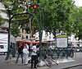 | 05-13 | 2 | 1 | 11 & 20 | 31 January 1903
Alma – Marceau | 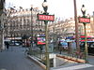 | 18-03 | 9 | 1 | 16 | 27 May 1923
Anatole France | 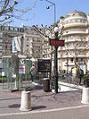 | 29-14 | 3 | 2 | Levallois-Perret | 24 September 1937
Anvers | 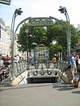 | 31-04 | 2 | 1 | 9 & 18 | 7 October 1902
Argentine | 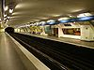 | 18-11 | 1 | 1 | 16 & 17 | 1 September 1900
Arts et Métiers | 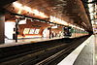 | 08-03 | 3 & 11 | 1 | 3 | 19 October 1904
Asnières – Gennevilliers – Les Courtilles | 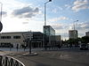 | 19-04 | 13 | 3 | Asnières-sur-Seine, Gennevilliers | 14 June 2008
Assemblée nationale | 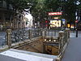 | 10-13 | 12 | 1 | 7 | 5 November 2010
Aubervilliers – Pantin – Quatre Chemins | 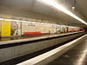 | 03-05 | 7 | 1 | Aubervilliers | 4 October 1979
Avenue Émile Zola | 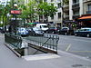 | 17-06 | 10 | 1 | 15 | 13 July 1913
Avron | 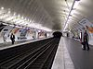 | 05-12 | 2 | 1 | 11 & 20 | 2 April 1903
Bagneux |  | — | 4 | — | Bagneux | 2014
Balard | 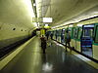 | 16-09 | 8 | 1 | 15 | 27 July 1937
Barbès – Rochechouart | 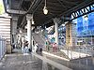 | 21-07 | 2 & 4 | 1 | 9, 10, 18 | 26 March 1903
Basilique de Saint-Denis | 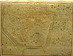 | 19-15 | 13 | 1 | Saint-Denis | 20 June 1976
Bastille | 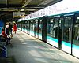 | 12-12 | 1, 5, 8 | 1 | 4, 11, 12 | 17 July 1900
Bel-Air | 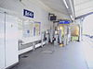 | 13-12 | 6 | 1 | 12 | 1 March 1909
Belleville | 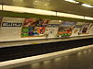 | 24-12 | 2 & 11 | 1 | 10, 11, 19, 20 | 1 January 1903
Bérault | 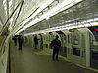 | 25-10 | 1 | 2 | Saint-Mandé, Vincennes | 24 March 1934
Bercy | 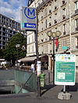 | 13-07 | 6 & 14 | 2 | 12 | 1 March 1909
Bibliothèque François Mitterrand | 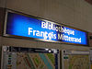 | 15-03 | 14 | 1 | 13 | 15 October 1998
Billancourt | 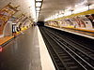 | 28-09 | 9 | 1 | Boulogne-Billancourt | 3 February 1934
Bir-Hakeim | 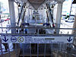 | 10-04 | 6 | 1 | 15 | 24 April 1906
Blanche | 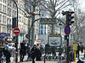 | 31-07 | 2 | 1 | 9, 18 | 21 October 1902
Bobigny – Pablo Picasso | 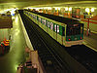 | 03-12 | 5 | 1 | Bobigny | 25 April 1985
Boissière | 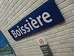 | 17-14 | 6 | 1 | 16 | 2 October 1900
Bolivar | 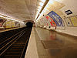 | 22-14 | 7bis | 1 | 19 | 18 July 1911
Bonne Nouvelle | 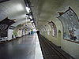 | 11-08 | 8 & 9 | 1 | 2, 9, 10 | 5 May 1931
Botzaris | 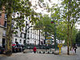 | 23-09 | 7bis | 1 | 19 | 18 January 1911
Boulogne – Jean Jaurès | 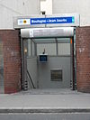 | 29-04 | 10 | 2 | Boulogne-Billancourt | 3 October 1980
Boulogne – Pont de Saint-Cloud | 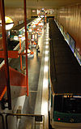 | 29-05 | 10 | 2 | Boulogne-Billancourt | 2 October 1981
Boucicaut | 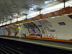 | 16-11 | 8 | 1 | 15 | 27 July 1937
Bourse | 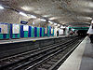 | 11-04 | 3 | 1 | 2 | 19 October 1904
Bréguet – Sabin | 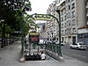 | 12-14 | 5 | 1 | 11 | 31 December 1906
Brochant | 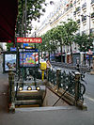 | 30-08 | 13 | 1 | 17 | 20 January 1912
Buttes Chaumont | 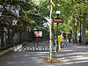 | 23-13 | 7bis | 1 | 19 | 13 February 1912
Buzenval | 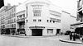 | 05-05 | 9 | 1 | 20 | 10 December 1933
Cadet | 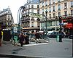 | 21-03 | 7 | 1 | 9 | 5 November 1910
Cambronne | 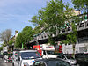 | 02-02 | 6 | 1 | 15 | 24 April 1906
Campo-Formio | 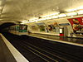 | 14-12 | 5 | 1 | 13 | 2 June 1906
Cardinal Lemoine | 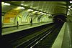 | 12-06 | 10 | 1 | 5 | 26 April 1931
Carrefour Pleyel | 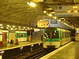 | 19-13 | 10 | 1 | Saint-Denis | 30 June 1952
Censier – Daubenton | 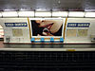 | 12-04 | 7 | 1 | 5 | 15 February 1930
Champs-Élysées – Clemenceau | 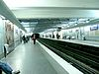 | 10-01 | 1 & 13 | 1 | 8 | 19 July 1900
Chardon Lagache | 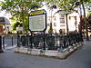 | 07-11 | 10 | 1 | 16 | 30 September 1913
Charenton – Écoles | 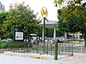 | 25-13 | 8 | 1 | Charenton-le-Pont | 5 October 1942
Charles de Gaulle – Étoile | 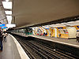 | 18-12 | 1, 2, 6 | 1 | 8, 16, 17 | 1 September 1900
Charles Michels | 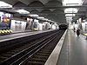 | 16-13 | 10 | 1 | 15 | 13 July 1913
Charonne | 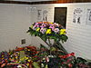 | 24-02 | 9 | 1 | 11 | 10 December 1933
Château d'Eau | 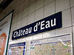 | 11-11 | 4 | 1 | 10 | 21 April 1908
Château de Vincennes | 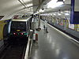 | 25-11 | 1 | 2 | 12 & Vincennes | 24 March 1934
Château-Landon | 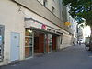 | 21-11 | 7 | 1 | 19 | 5 November 1910
Château Rouge |  | 21-04 | 4 | 1 | 18 | 21 April 1908
Châtelet | 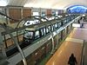 | 01-08 | 1, 4, 7, 11, 14 | 1 | 1 & 4 | 6 August 1900
Châtillon – Montrouge | 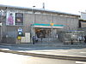 | 27-09 | 13 | 1 | Châtillon,  Montrouge | 9 November 1976
Chaussée d'Antin – La Fayette | 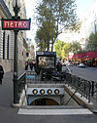 | 21-01 | 7 & 9 | 1 | 9 | 5 November 1910
Chemin Vert | 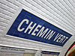 | 12-13 | 8 | 1 | 9 & 11 | 5 May 1931
Chevaleret | 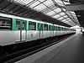 | 09-02 | 6 | 1 | 13 | 1 March 1909
Cité | 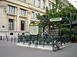 | 01-14 | 4 | 1 | 4 | 9 January 1910
Cluny – La Sorbonne | 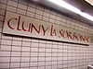 | 01-05 | 10 | 1 | 5 | 15 February 1930
Colonel Fabien | 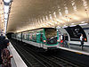 | 22-15 | 2 | 1 | 10 & 19 | 31 January 1903
Commerce | 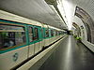 | 17-05 | 8 | 1 | 15 | 27 July 1937
Concorde | 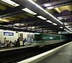 | 10-02 | 1, 8, 12 | 1 | 1 & 8 | 13 August 1900
Convention | 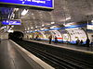 | 16-05 | 12 | 1 | 15 | 5 November 1910
Corentin Cariou | 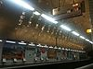 | 22-04 | 7 | 1 | 19 | 5 November 1910
Corentin Celton | 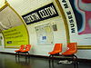 | 28-02 | 12 | 2 | Issy-les-Moulineaux | 24 March 1934
Corvisart | 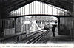 | 14-15 | 6 | 1 | 13 | 24 April 1906
Cour Saint-Émilion | 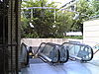 | 15-01 | 14 | 1 | 12 | 15 October 1998
Courcelles | 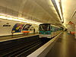 | 18-15 | 2 | 1 | 8 & 17 | 7 October 1902
Couronnes | 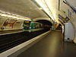 | 24-13 | 2 | 1 | 11 & 20 | 31 January 1903
Créteil – l’Échat |  | 25-05 | 8 | 1 | Créteil | 24 September 1973
Créteil – Préfecture | 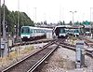 | 25-07 | 8 | 1 | Créteil | 9 September 1974
Créteil – Université | 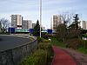 | 25-06 | 8 | 1 | Créteil | 9 September 1974
Crimée | 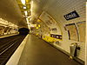 | 22-06 | 7 | 1 | 19 | 5 November 1910
Croix de Chavaux | 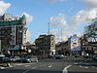 | 25-02 | 9 | 1 | Montreuil | 14 October 1937
Danube | 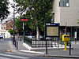 | 23-10 | 7bis | 1 | 19 | 18 January 1911
Daumesnil | 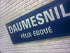 | 13-11 | 6 & 8 | 1 | 12 | 1 March 1909
Denfert-Rochereau | 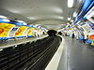 | 15-14 | 4 & 6 | 1 | 14 | 24 April 1906
Dugommier | 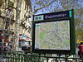 | 13-08 | 6 | 1 | 12 | 1 March 1909
Dupleix |  | 17-07 | 6 | 1 | 15 | 24 April 1906
Duroc | 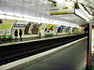 | 02-07 | 6 & 10 | 1 | 6, 7, 15 | 30 December 1923
École Militaire | 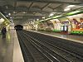 | 10-07 | 8 | 1 | 7 | 13 July 1913
École Vétérinaire de Maisons-Alfort | 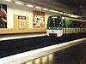 | 25-14 | 8 | 1 | Maisons-Alfort | 19 September 1970
Edgar Quinet | 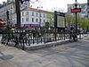 | 04-06 | 6 | 1 | 14 | 24 April 1906
Église d’Auteuil | 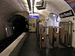 | 07-08 | 10 | 1 | 16 | 30 September 1913
Église de Pantin | 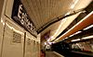 | 03-10 | 5 | 1 | Pantin | 12 October 1942
Esplanade de la Défense | 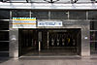 | 29-10 | 1 | 2-3 | Courbevoie, Puteaux | 1 April 1992
Étienne Marcel | 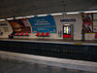 | 11-15 | 4 | 1 | 1 & 2 | 21 April 1908
Europe | 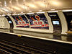 | 06-12 | 3 | 1 | 8 | 19 October 1904
Exelmans | 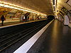 | 07-14 | 9 | 1 | 16 | 8 November 1922
Faidherbe – Chaligny | 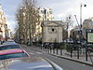 | 12-01 | 8 | 1 | 11 & 12 | 5 May 1931
Falguière | 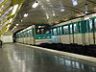 | 16-01 | 12 | 1 | 15 | 5 November 1910
Félix Faure |  | 16-12 | 8 | 1 | 15 | 27 July 1937
Filles du Calvaire | 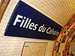 | 08-12 | 8 | 1 | 3 & 11 | 5 May 1931
Fort d’Aubervilliers | 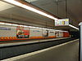 | 03-06 | 7 | 2 | Aubervilliers | 4 October 1979
Franklin D. Roosevelt | 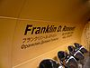 | 18-07 | 1 & 9 | 1 | 8 | 19 July 1900
Gabriel Péri | 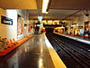 | 19-02 | 13 | 3 | Asnières-sur-Seine, Gennevilliers | 3 May 1980
Gaîté | 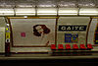 | 04-04 | 13 | 1 | 14 | 21 January 1937
Gallieni |  | 23-05 | 3 | 1 | Bagnolet | 2 April 1971
Gambetta | 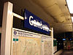 | 24-10 | 3 & 3bis | 1 | 20 | 27 March 1905
Gare d’Austerlitz | 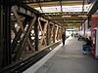 | 09-07 | 5 & 10 | 1 | 5 & 13 | 2 June 1906
Gare de l’Est | 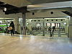 | 21-09 | 4, 5, 7 | 1 | 10 | 15 November 1907
Gare de Lyon | 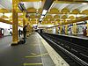 | 09-08 | 1, 14 | 1 | 12 | 19 July 1900
Gare du Nord | 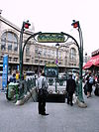 | 21-08 | 4, 5 | 1 | 10 | 21 April 1908
George V | 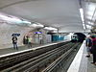 | 18-08 | 1 | 1 | 8 | 13 August 1900
Glacière | 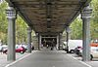 | 15-08 | 6 | 1 | 13 | 24 April 1906
Goncourt | 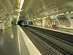 | 08-05 | 11 | 1 | 10 & 11 | 28 April 1935
Grands Boulevards | 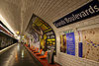 | 11-06 | 8 & 9 | 1 | 2 & 9 | 5 May 1931
Guy Môquet | 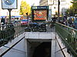 | 30-12 | 13 | 1 | 17 & 18 | 26 February 1911
Havre – Caumartin | 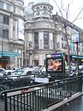 | 06-07 | 3 & 9 | 1 | 9 | 19 October 1904
Hoche | 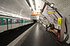 | 03-09 | 5 | 2 | Pantin | 12 October 1942
Hôtel de Ville | 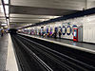 | 01-15 | 1, 9, 11 | 1 | 4 | 19 July 1900
Invalides | 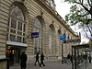 | 10-09 | 8, 13 | 1 | 7 | 13 July 1913 | Hôtel des Invalides
Jacques Bonsergent | 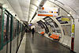 | 08-04 | 5 | 1 | 10 | 17 December 1906
Jasmin | 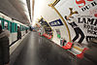 | 07-15 | 9 | 1 | 16 | 8 November 1922
Jaurès | 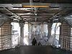 | 22-12 | 2, 5, 7bis | 1 | 10, 19 | 23 February 1903
Javel – André Citroën | 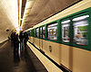 | 16-14 | 10 | 1 | 15 | 30 September 1913
Jourdain | 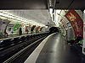 | 23-14 | 11 | 1 | 19, 20 | 28 April 1935
Jules Joffrin | 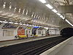 | 20-11 | 12 | 1 | 18 | 31 October 1912
Jussieu | 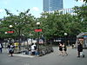 | 12-07 | 7, 10 | 1 | 5 | 26 April 1931
Kléber | 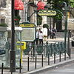 | 18-09 | 6 | 1 | 16 | 2 October 1900
La Chapelle | 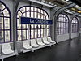 | 22-09 | 2 | 1 | 10 & 18 | 31 January 1903
La Courneuve – 8 Mai 1945 | 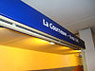 | 03-07 | 7 | 2 | Saint-Denis | 6 May 1987
La Défense – Grande Arche | 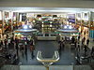 | 29-00 | 1 | 3 | Puteaux | 1 April 1992
La Fourche | 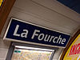 | 31-14 | 13 | 1 | 17 & 18 | 26 February 1911
La Motte-Picquet – Grenelle | 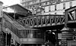 | 17-04 | 6, 8, 10 | 1 | 15 | 24 April 1906
La Muette | 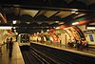 | 17-11 | 9 | 1 | 16 | 8 November 1922
La Tour-Maubourg | 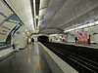 | 10-08 | 8 | 1 | 7 | 13 July 1913
Lamarck – Caulaincourt | 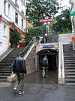 | 20-12 | 12 | 1 | 18 | 31 October 1912
Laumière | 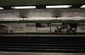 | 22-13 | 5 | 1 | 19 | 12 October 1942
Le Kremlin-Bicêtre |  | 26-06 | 7 | 2 | Le Kremlin-Bicêtre | 10 October 1982
Le Peletier | 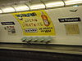 | 21-02 | 7 | 1 | 9 | 6 June 1911
Ledru-Rollin | 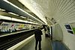 | 12-15 | 8 | 1 | 11 & 12 | 5 May 1931
Les Agnettes | 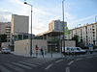 | 19-03 | 13 | 3 | Asnières-sur-Seine, Gennevilliers | 14 June 2000
Les Gobelins | 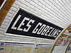 | 14-13 | 7 | 1 | 5 & 13 | 15 February 1930
Les Halles | 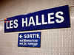 | 01-09 | 4 | 1 | 1 | 21 April 1908
Les Sablons | 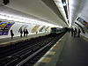 | 29-08 | 1 | 2 | Neuilly-sur-Seine | 29 April 1937
Liberté | 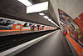 | 25-12 | 8 | 1 | Charenton-le-Pont | 5 October 1942
Liège | 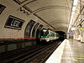 | 06-13 | 13 | 1 | 8 & 9 | 26 February 1911
Louis Blanc | 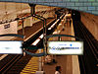 | 22-10 | 7 & 7bis | 1 | 10 | 23 November 1910
Louise Michel | 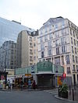 | 29-13 | 3 | 2 | Levallois-Perret | 24 September 1937
Lourmel | 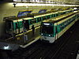 | 16-10 | 8 | 1 | 15 | 27 July 1937
Louvre – Rivoli | 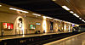 | 01-12 | 1 | 1 | 1 | 13 August 1900
Mabillon |  | 02-14 | 10 | 1 | 6 | 10 March 1925
Madeleine | 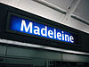 | 10-03 | 8, 12, 14 | 1 | 8 | 5 November 1910
Mairie d'Issy | 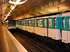 | 28-03 | 12 | 2 | Issy-les-Moulineaux | 24 March 1934
Mairie d’Ivry | 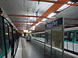 | 26-05 | 7 | 1 | Ivry-sur-Seine | 1 May 1946
Mairie de Clichy | 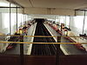 | 19-01 | 13 | 2 | Clichy | 3 May 1980
Mairie de Montreuil | 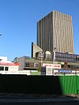 | 25-03 | 9 | 1 | Montreuil | 14 October 1937
Mairie de Montrouge | 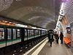 |  | 4 | 1 | Montrouge | 23 March 2013
Mairie de Saint-Ouen | 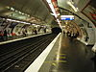 | 19-11 | 13 | 1 | Saint-Ouen, Seine-Saint-Denis | 30 June 1952
Mairie des Lilas | 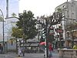 | 23-03 | 11 | 1 | Les Lilas | 17 February 1937
Maison Blanche | 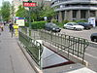 | 14-09 | 7 | 1 | 13 | 7 March 1930
Maisons-Alfort – Les Juilliottes |  | 25-04 | 8 | 1 | Maisons-Alfort | 24 April 1972
Maisons-Alfort – Stade | 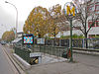 | 25-15 | 8 | 1 | Maisons-Alfort | 19 September 1970
Malakoff – Plateau de Vanves | 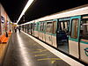 | 27-07 | 13 | 1 | Malakoff | 9 November 1976
Malakoff – Rue Étienne Dolet | 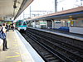 | 27-08 | 13 | 1 | Malakoff | 9 November 1976
Malesherbes | 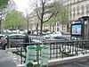 | 06-01 | 3 | 1 | 17 | 23 May 1910
Maraîchers | 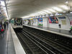 | 05-04 | 9 | 1 | 20 | 10 December 1933
Marcadet – Poissonniers | 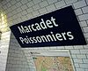 | 20-09 | 4 & 12 | 1 | 18 | 21 April 1908
Marcel Sembat | 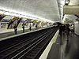 | 28-08 | 9 | 1 | Boulogne-Billancourt | 3 February 1934
Marx Dormoy | 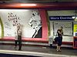 | 20-07 | 12 | 1 | 18 | 23 August 1916
Maubert-Mutualité | 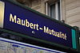 | 01-06 | 10 | 1 | 5 | 15 February 1930
Ménilmontant | 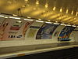 | 24-05 | 2 | 1 | 11 & 20 | 31 January 1903
Michel Bizot | 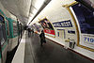 | 13-10 | 8 | 1 | 12 | 5 May 1931
Michel-Ange – Auteuil | 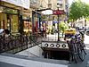 | 07-09 | 9 & 10 | 1 | 16 | 30 September 1913
Michel-Ange – Molitor | 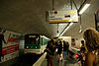 | 07-10 | 9 & 10 | 1 | 16 | 30 September 1913
Mirabeau | 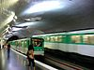 | 07-12 | 10 | 1 | 16 | 30 September 1913
Miromesnil | 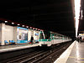 | 18-04 | 9 & 13 | 1 | 8 | 27 May 1923 | Élysée Palace, Musée Jacquemart-André
Monceau | 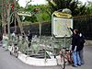 | 06-02 | 2 | 1 | 8 & 17 | 7 October 1902 | Parc Monceau, Musée Cernuschi, Musée Nissim de Camondo
Montgallet | 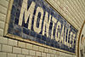 | 12-03 | 8 | 1 | 12 | 5 May 1931 | Promenade plantée
Montparnasse – Bienvenüe | 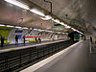 | 04-08 | 4, 6, 12, 13 | 1 | 6, 14, 15 | 24 April 1906
Mouton-Duvernet | 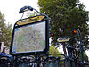 | 15-04 | 4 | 1 | 14 | 30 October 1909
Nation | 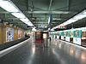 | 05-10 | 1, 2, 6, 9 | 1 | 11 & 12 | 2 April 1903 | Place de la Nation
Nationale | 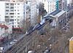 | 14-11 | 6 | 1 | 13 | 1 March 1909
Notre-Dame-de-Lorette | 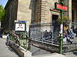 | 31-09 | 12 | 1 | 9 | 5 November 1910 | Notre-Dame-de-Lorette
Notre-Dame-des-Champs | 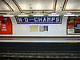 | 04-14 | 12 | 1 | 6 | 5 November 1910
Oberkampf | 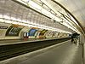 | 08-10 | 5 & 9 | 1 | 11 | 15 January 1907
Odéon | 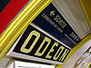 | 01-04 | 4 & 10 | 1 | 6 | 9 January 1910 | Palais du Luxembourg
Olympiades | 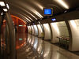 | 15-06 | 14 | 1 | 13 | 26 June 2007
Opéra | 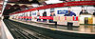 | 06-05 | 7 & 8 | 1 | 2 & 9 | 5 November 1910 | Opéra Garnier
Ourcq | 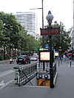 | 22-02 | 5 | 1 | 19 | 21 March 1947 | Canal de l'Ourcq
Palais Royal – Musée du Louvre | 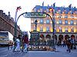 | 11-02 | 1 & 7 | 1 | 1 | 19 July 1900 | Palais Royal, Louvre
Parmentier | 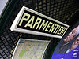 | 08-11 | 3 | 1 | 11 | 19 October 1904
Passy | 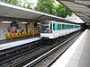 | 17-08 | 6 | 1 | 16 | 6 November 1903 | Maison de Radio France
Pasteur | 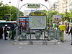 | 16-02 | 6 & 12 | 1 | 15 | 24 April 1906 | Institut Pasteur
Pelleport | 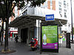 | 24-09 | 3bis | 1 | 20 | 27 November 1921
Père Lachaise | 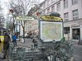 | 24-04 | 2 & 3 | 1 | 11 & 20 | 25 February 1903 | Cimetière Père Lachaise
Pereire |  | 30-05 | 3 | 1 | 17 | 23 May 1910
Pernety | 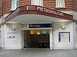 | 04-02 | 13 | 1 | 14 | 21 January 1937
Philippe Auguste | 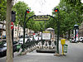 | 24-07 | 2 | 1 | 11 & 20 | 31 January 1903 | Cimetière Père Lachaise
Picpus | 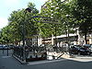 | 05-09 | 3 & 3bis | 1 | 12 | 1 March 1909 | Cimetière de Picpus
Pierre et Marie Curie | 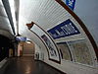 | 26-04 | 7 | 1 | Ivry-sur-Seine | 1 May 1946
Pigalle | 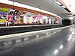 | 31-06 | 2 & 12 | 1 | 9 & 18 | 7 October 1902 | Quartier Pigalle
Place d'Italie | 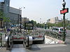 | 14-14 | 5, 6, 7 | 1 | 13 | 24 April 1906 | Butte-aux-Cailles
Place de Clichy | 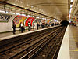 | 31-13 | 2 & 13 | 1 | 8, 9, 17, 18 | 7 October 1902 | Cimetière de Montmartre
Place des Fêtes | 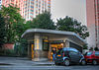 | 23-08 | 7bis & 11 | 1 | 19 | 18 July 1911 | Belleville
Place Monge | 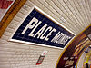 | 12-05 | 7 | 1 | 5 | 15 February 1930 | Jardin des Plantes, Arènes de Lutèce
Plaisance | 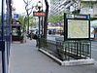 | 04-03 | 13 | 1 | 14 | 21 January 1937
Pointe du Lac | 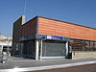 |  | 8 | 1 | Créteil | 8 October 2011 | Stade Dominique Duvauchelle
Poissonnière | 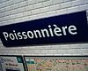 | 21-10 | 7 | 1 | 9 & 10 | 5 November 1910
Pont de Levallois – Bécon | 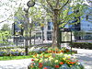 | 29-15 | 3 | 2 | Levallois-Perret | 24 September 1937
Pont de Neuilly | 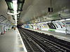 | 29-09 | 1 | 2 | Neuilly-sur-Seine | 29 April 1937
Pont de Sèvres | 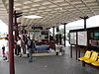 | 28-10 | 9 | 1 | Boulogne-Billancourt | 3 February 1934
Pont Marie | 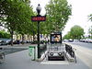 | 12-09 | 7 | 1 | 4 | 16 April 1926
Pont Neuf | 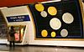 | 01-13 | 7 | 1 | 1 | 16 April 1926 | Pont Neuf, Conciergerie
Porte d’Auteuil | 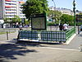 | 07-07 | 10 | 1 | 16 | 30 September 1913 | Parc des Princes, Stade Jean-Bouin, Jardin des Serres d'Auteuil, Auteuil Hippodrome, Bois de Boulogne
Porte d’Italie | 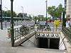 | 14-03 | 7 | 1 | 13 | 7 March 1930
Porte d’Ivry | 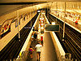 | 26-03 | 7 | 1 | 13 | 26 April 1931
Porte d’Orléans | 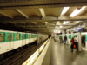 | 15-02 | 4 | 1 | 14 | 30 October 1909
Porte Dauphine | 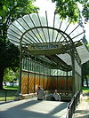 | 17-02 | 2 | 1 | 16 | 13 December 1900
Porte de Bagnolet | 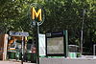 | 23-04 | 3 | 1 | 20 | 2 April 1971
Porte de Champerret | 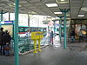 | 29-12 | 3 | 1 | 17 | 15 February 1911
Porte de Charenton | 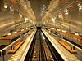 | 13-03 | 8 | 1 | 12 | 5 May 1931
Porte de Choisy | 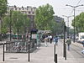 | 14-02 | 7 | 1 | 13 | 7 March 1930
Porte de Clichy | 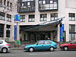 | 30-09 | 13 | 1 | 17 | 20 January 1912
Porte de Clignancourt | 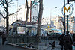 | 20-01 | 4 | 1 | 18 | 21 April 1908 | Cimetière parisien de Saint-Ouen, Marché aux puces de Paris
Porte de la Chapelle | 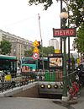 | 20-06 | 12 | 1 | 18 | 23 August 1916
Porte de la Villette | 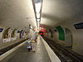 | 03-04 | 7 | 1 | 19 | 5 November 1910 | Cité des Sciences et de l'Industrie, Parc de la Villette, La Géode
Porte de Montreuil | 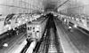 | 05-03 | 9 | 1 | 20 | 10 December 1933
Porte de Pantin | 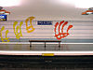 | 22-01 | 5 | 1 | 19 | 12 October 1942 | Parc de la Villette, Cité de la musique, Zénith de Paris, Conservatoire de Paris
Porte de Saint-Cloud | 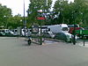 | 07-03 | 9 | 1 | 16 | Parc des Princes
Porte de Saint-Ouen | 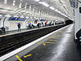 | 30-13 | 13 | 1 | 17 & 18 | 26 February 1911
Porte de Vanves | 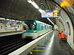 | 27-02 | 13 | 1 | 14 | 21 January 1937
Porte de Versailles | 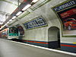 | 16-06 | 12 | 1 | 15 | 5 November 1910
Porte de Vincennes | 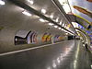 | 05-07 | 1 | 1 | 12 & 20 | 19 July 1900
Porte des Lilas | 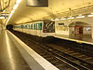 | 23-02 | 3bis & 11 | 1 | 19 & 20 | 27 November 1921
Porte Dorée | 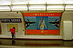 | 13-01 | 8 | 1 | 12 | 5 May 1931 | Bois de Vincennes
Porte Maillot | 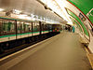 | 30-01 | 1 | 1 | 16 & 17 | 19 July 1900 | Palais des congrès de Paris
Pré Saint-Gervais | 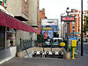 | 23-11 | 7bis | 1 | 19 | 18 January 1911
Pyramides | 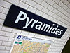 | 11-03 | 7 & 14 | 1 | 1 | 1 July 1916
Pyrénées | 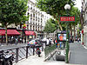 | 24-14 | 11 | 1 | 19 & 20 | 28 April 1935 | Parc de Belleville, Parc des Buttes-Chaumont
Quai de la Gare | 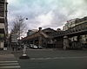 | 09-01 | 6 | 13 | 1 | 1 March 1909 | Palais Omnisports de Paris-Bercy
Quai de la Rapée | 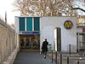 | 09-10 | 5 | 1 | 12 | 13 July 1906
Quatre-Septembre | 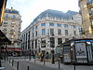 | 06-04 | 3 | 1 | 2 | 3 November 1904 | Bibliothèque nationale de France
Rambuteau | 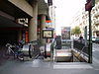 | 08-01 | 11 | 1 | 3 & 4 | 28 April 1935 | Centre Georges Pompidou, Stravinsky Fountain
Ranelagh | 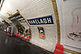 | 17-09 | 9 | 1 | 16 | 8 November 1922
Raspail | 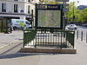 | 15-10 | 4 & 6 | 1 | 14 | 24 April 1906 | Fondation Cartier, Montparnasse Cemetery
Réaumur – Sébastopol | 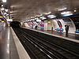 | 11-14 | 3 & 4 | 1 | 2 & 3 | 19 October 1904 | Musée des Arts et Métiers
Rennes | 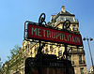 | 02-11 | 12 | 1 | 6 | 5 November 1910
République | 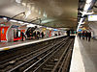 | 08-07 | 3, 5, 8, 9, 11 | 1 | 3, 10, 11 | 19 October 1904
Reuilly – Diderot | 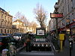 | 12-02 | 1 & 8 | 1 | 12 | 20 August 1900
Richard-Lenoir | 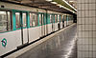 | 08-14 | 5 | 1 | 11 | 17 December 1906
Richelieu – Drouot |  | 11-07 | 8 & 9 | 1 | 2 & 9 | 30 June 1928
Riquet | 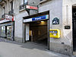 | 22-08 | 7 | 1 | 19 | 5 November 1910 | Canal de l'Ourcq
Robespierre | 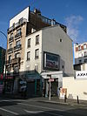 | 05-02 | 9 | 1 | Montreuil | 14 October 1937
Rome | 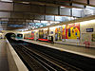 | 31-12 | 2 | 1 | 8 & 17 | 6 November 1902
Rue de la Pompe | 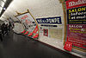 | 07-13 | 9 | 1 | 16 | 8 November 1922
Rue des Boulets | 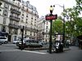 | 05-06 | 9 | 1 | 11 | 10 December 1933
Rue du Bac | 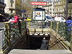 | 02-10 | 12 | 1 | 7 | 5 November 1910 | Hôtel Matignon, Maison de Verre
Rue Saint-Maur | 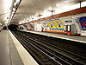 | 24-06 | 3 | 1 | 11 | 19 October 1904 | ESCP Europe
Saint-Ambroise | 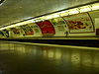 | 08-15 | 9 | 1 | 11 | 10 December 1933
Saint-Augustin | 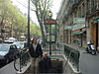 | 06-10 | 9 | 1 | 8 | 27 May 1923 | Saint-Augustin
Saint-Denis – Porte de Paris | 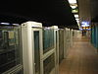 | 19-14 | 13 | 1 | Saint-Denis | 26 May 1976 | Stade de France
Saint-Denis – Université | 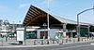 | 10-11 | 13 | 1 | Saint-Denis | 25 May 1998
Saint-Fargeau | 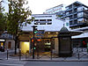 | 24-08 | 3bis | 1 | 20 | 27 November 1921
Saint-François-Xavier | 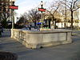 | 02-06 | 13 | 1 | 7 | 30 December 1923
Saint-Germain-des-Prés | 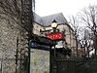 | 02-15 | 4 | 1 | 6 | 9 January 1910 | Saint-Germain-des-Prés, Abbey of Saint-Germain-des-Prés, Café de Flore, Les Deux Magots
Saint-Georges | 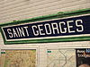 | 31-10 | 12 | 1 | 9 | 8 April 1911
Saint-Jacques | 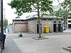 | 15-09 | 6 | 1 | 14 | 24 April 1906 | La Santé
Saint-Lazare | 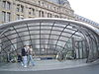 | 06-09 | 3, 12, 13, 14 | 1 | 8 & 9 | 19 October 1904
Saint-Mandé | 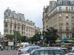 | 25-08 | 1 | 2 | Saint-Mandé | 24 March 1934 | Institut géographique national, Bois de Vincennes
Saint-Marcel | 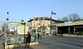 | 09-04 | 5 | 1 | 13 | 2 June 1906
Saint-Michel | 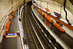 | 01-01 | 4 | 1 | 5 & 6 | 9 September 1910 | Quartier Latin, Fontaine Saint-Michel
Saint-Paul | 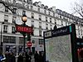 | 12-10 | 1 | 1 | 4 | 6 August 1900 | Pletzl
Saint-Philippe du Roule | 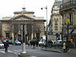 | 18-05 | 9 | 1 | 8 | 27 May 1923
Saint-Placide | 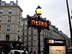 | 04-12 | 4 | 1 | 6 | 9 January 1910
Saint-Sébastien – Froissart | 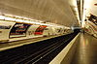 | 08-13 | 8 | 1 | 3 & 11 | 5 May 1931
Saint-Sulpice | 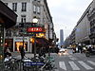 | 02-12 | 4 | 1 | 6 | 9 January 1910
Ségur | 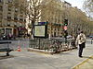 | 02-04 | 10 | 1 | 7 & 15 | 29 July 1937
Sentier | 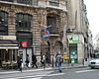 | 11-13 | 3 | 1 | 2 | 20 November 1904
Sèvres – Babylone | 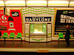 | 02-09 | 10 & 12 | 1 | 6 & 7 | 5 November 1910
Sèvres – Lecourbe | 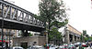 | 02-03 | 6 | 1 | 15 | 24 April 1906
Simplon | 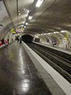 | 20-10 | 4 | 1 | 18 | 14 May 1908
Solférino | 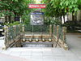 | 10-14 | 12 | 1 | 7 | 5 November 1910
Stalingrad | 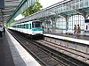 | 22-11 | 2, 5, 7 | 1 | 10, 19 | 31 January 1903
Strasbourg – Saint-Denis | 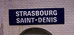 | 11-10 | 4, 8, 9 | 1 | 2, 3, 10 | 5 May 1908
Sully – Morland | 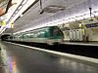 | 12-08 | 7 | 1 | 4 | 3 June 1930
Télégraphe | 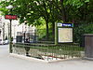 | 23-15 | 11 | 1 | 19 & 20 | 28 April 1935
Temple | 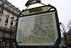 | 08-06 | 3 | 1 | 3 | 19 October 1904
Ternes | 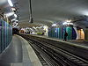 | 18-14 | 2 | 1 | 8 & 17 | 7 October 1902
Tolbiac | 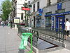 | 14-10 | 7 | 1 | 13 | 7 March 1930
Trinité – d'Estienne d'Orves | 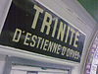 | 31-08 | 12 | 1 | 9 | 5 November 1910
Trocadéro | 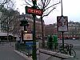 | 17-15 | 6 & 9 | 1 | 16 | 2 January 1900
Tuileries | 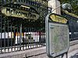 | 11-01 | 1 | 1 | 1 | 19 July 1900
Vaneau | 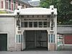 | 02-08 | 10 | 1 | 6 & 7 | 30 December 1923
Varenne | 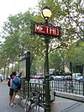 | 10-12 | 13 | 1 | 7 | 30 December 1923
Vaugirard | 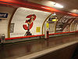 | 16-04 | 12 | 1 | 15 | 5 November 1910
Vavin | 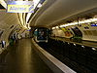 | 04-07 | 4 | 1 | 6 & 14 | 9 January 1910
Verdun-Sud |  | — | 4 | — | Bagneux, Montrouge | 2014
Victor Hugo | 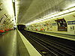 | 18-10 | 2 | 1 | 16 | 13 December 1900
Villejuif – Léo Lagrange | 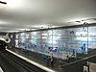 | 26-07 | 7 | 2 | Villejuif | 28 February 1985
Villejuif – Louis Aragon | 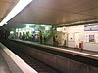 | 26-09 | 7 | 2 | Villejuif | 28 February 1985
Villejuif – Paul Vaillant-Couturier | 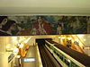 | 26-08 | 7 | 2 | Villejuif | 28 February 1985
Villiers | 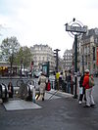 | 06-03 | 2 & 3 | 1 | 8 & 17 | 19 October 1904
Volontaires | 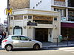 | 16-03 | 12 | 1 | 15 | 5 November 1910
Voltaire | 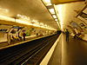 | 24-01 | 9 | 1 | 11 | 10 December 1933
Wagram | 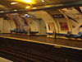 | 30-04 | 3 | 1 | 17 | 23 May 1910

